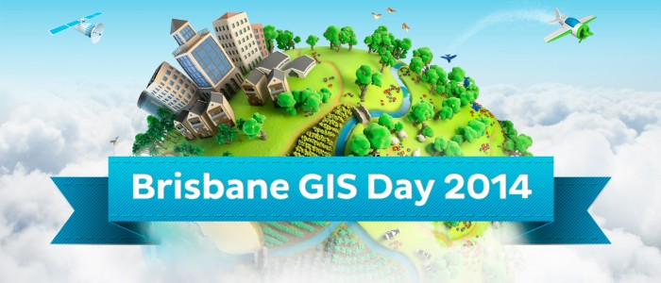

Over 2000 People Attend GIS Day in Brisbane
November 25, 2014News
Last Wednesday GIS People hosted Australia’s largest GIS conference for this year – Brisbane GIS Day. With so much to see and do, visitors started arriving at QUT even before 9am, when the day officially opened. Throughout the day, there was a constant flow of business leaders, professionals, academics, students, politicians and hobbyists coming to see 3D printing, Google Glass, a satellite showcase, plus some very exciting presentations.
ABC radio conducted a live interview with Dr Tim Foresman at 10am, causing a further influx of visitors for the lunch and afternoon sessions. The exhibitors reported being completely inundated with interest from so many day visitors. GIS People’s Event Manager, Rachelle Leembruggen, says: “Without help from our many volunteers we don’t know how we would have got through the day – thank you to all who helped. And due to the massive turnout we ran out of show bags, so we apologise to those who missed out.”
Positive feedback has been flowing in from attendees, exhibitors and presenters. Platinum sponsors Dialog said: “The team from Dialog were extremely pleased with our sponsorship of the GIS Day this year. It is easily the best spatial industry event in Australia, and the amount of traffic in the exhibition area is impressive. Well done to GIS People!” – Glenn Irvine, National Practice Manager – Google Solutions.
The HERE-sponsored Map App Hack event ensured a grand-finale finish for the day, with 3 finalists battling it out for the top prize of $5,000. The competition was won by Stephen Donaldson with his Benchmrk app. There were many other prize draws and competitions that will be announced in the coming days.
The celebrations continued via an exclusive VIP cocktail party at Old Parliament House. Not even a mighty afternoon storm triggering the building evacuation alarm could stop the many guests from attending, including senior government officials and police leaders. An awesome (and delicious) GIS Day cake of course also featured at the party.
All in all, GIS People hosted the world’s largest GIS Day event, and Australia’s largest GIS conference yet again in Brisbane. Next year is set to be even bigger. Watch out for more information soon from GIS People.
Check out our social media pages and www.gisday.com.au for great photos of the event!

